From Labs to Households – Agentic AI’s Rapid Rise
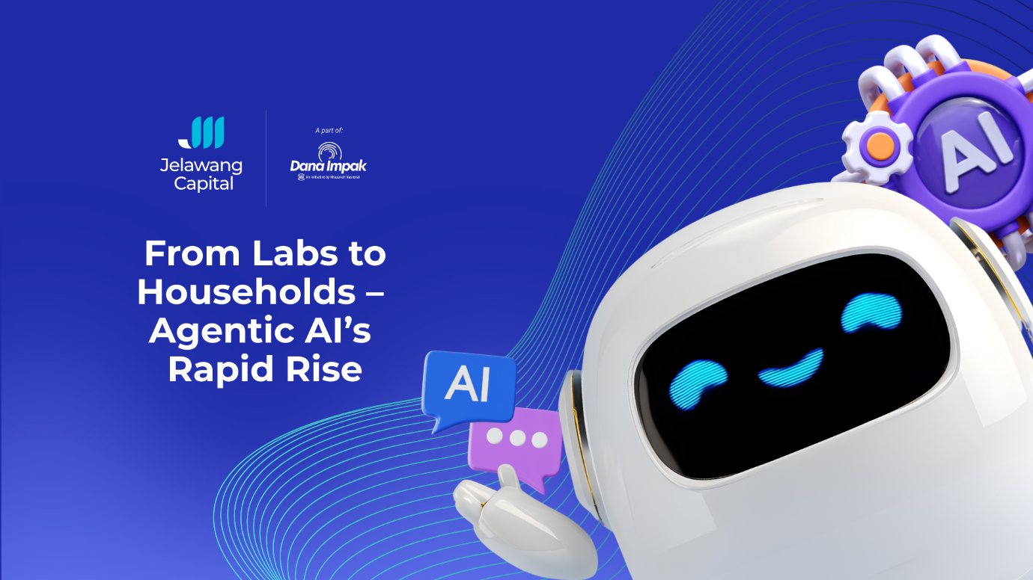

Agentic artificial intelligence (AI) is rapidly emerging as the next major frontier in digital innovation. After predictive AI and generative AI, this is the ‘third wave’ that is set to reshape our daily lives.
What sets agentic AI apart is its capability to complete tasks with minimal human intervention, moving beyond traditional models that generate content or answer questions. Instead, agentic AI can reason, take action, and coordinate workflows across multiple tools and platforms.
The transformative effects are significant for both businesses and people. Banks now use agentic AI to detect anomalous patterns in customer habits by monitoring thousands of data points including credit exposure and daily transactions.
Meanwhile, individuals now rely on AI agents to manage schedules, organise inboxes, and automate administrative tasks that traditionally consumed hours of manual effort.
Agentic AI solutions have been introduced for use in our personal lives, whether to delegate household management, undertake financial planning, or craft wellness routines. Underpinning this technology are intelligent assistants capable of learning preferences and executing an individual’s personalised plans.
Over time, these agents will evolve into proactive partners that anticipate needs, provide strategic recommendations, and coordinate digital activities seamlessly across platforms.

Explainer : Agentic AI vs. Generative AI
Aspect | Generative AI | Agentic AI
Core Function | Creates content (text, images, code, etc.) | Takes actions to achieve goals
Primary Capability | Prompt based  Content generation | Complete task ownership  Planning, decision-making, and tool usage
Autonomy Level | Reactive — responds when asked | Proactive — can act with minimal prompting
Examples | ChatGPT generating text, Midjourney images, Copilot summarising documents | AI that books meetings, manages workflows, or executes tasks end-to-end
Typical Output | Text, images, audio, code | Completed tasks, executed operations, multi-step workflows
Main Strength | Creativity and expressive generation | Automation and goal-oriented action
Analogy | A creator (writer/artist) | An assistant or agent that “gets things done”
Key Idea | Makes stuff | Does stuff

Agentic AI’s impact is already visible across real-world applications. Companies such as OpenAI, Anthropic, and Google DeepMind have introduced AI agents capable of autonomously booking travel, analysing financial data, drafting legal summaries, and orchestrating business processes end to end.
For example, Anthropic’s ‘action agents' can navigate enterprise systems, pull records, update databases, and execute transactions with human-level reliability.
Meanwhile, OpenAI’s advanced agents can interact with devices, manage tasks, and perform multi-step reasoning, reducing the need for manual oversight. These innovations illustrate how quickly Agentic AI is transitioning from concept to practical day-to-day usage.
In the workplace, agentic AI is reshaping operational efficiency. Teams can deploy agents that monitor market conditions, generate reports, manage compliance checks, or streamline procurement workflows.
This shift is expected to reduce repetitive tasks, elevate decision-making quality, and empower employees to focus on higher-value activities requiring human judgment, creativity, and collaboration.

How VC Backs Transformative Technology
As early stage backers of revolutionary idea, venture capital (VC) backing in this space sends a strong signal: agentic AI is poised to reshape industries and redefine how individuals and organisations operate in their daily lives.
Venture funding into the agentic AI space was on track to hit $6.7 billion in 2025, according to Prosus, with capital deployed into more than 1,500 startups globally.
However, this number is a fraction of overall investment activity in the AI space, driven by increased valuations in global leaders including OpenAI and Anthropic. Global VC funding rose 47 per cent to $469 billion in 2025, according to CB Insights report.
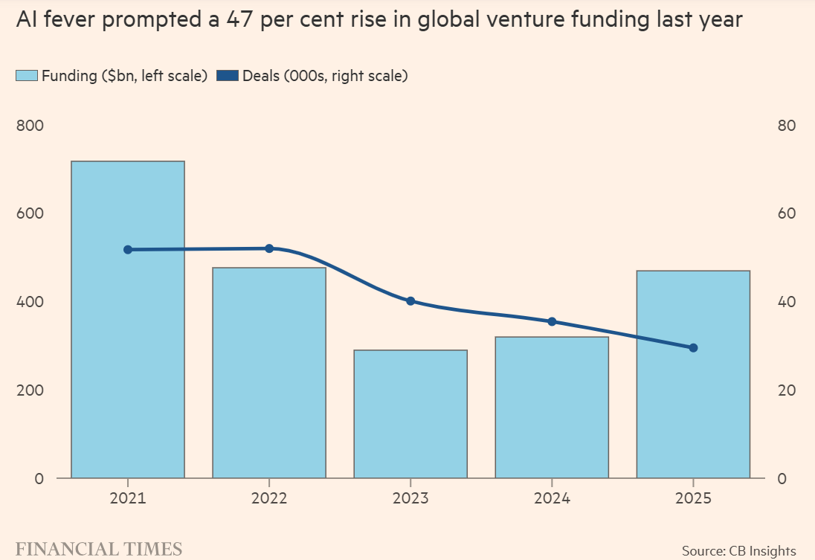

VC firms play a central role in driving this evolution by providing capital, expertise, and market access to the next generation of AI innovators.
Early-stage funding enables startups to scale research, attract talent, and refine safety protocols essential for responsible deployment. Growth investors support commercial adoption by connecting AI companies to global partners, regulators, and enterprise clients.
Through sustained investments, the VC ecosystem accelerates technological breakthroughs while ensuring that Agentic AI development remains aligned with broader economic and societal goals.

Malaysia’s Strategic Position
Southeast Asia’s digital economy is expanding rapidly, creating fertile ground for agentic AI adoption. Malaysia is well positioned to benefit from this regional shift, driven by strong e-commerce, logistics, and fintech ecosystems. As companies confront rising labour costs and scaling complexity, agentic AI offers a pathway to enhanced productivity and operational resilience.
Cognisant of this shift, the National AI Action Plan 2030 sets out to emphasise productivity uplift, digital transformation, and the development of high-value technology sectors.
As defined in the 13th Malaysia Plan (RMK-13), an AI Nation refers to a country with AI-technology integrated holistically as the main thrust in socioeconomic development, national administration and daily lives of the rakyat. These include government driven initiatives for Malaysian citizens to adopt AI and for AI solutions to be integrated into public services, and for business use by the private sector.

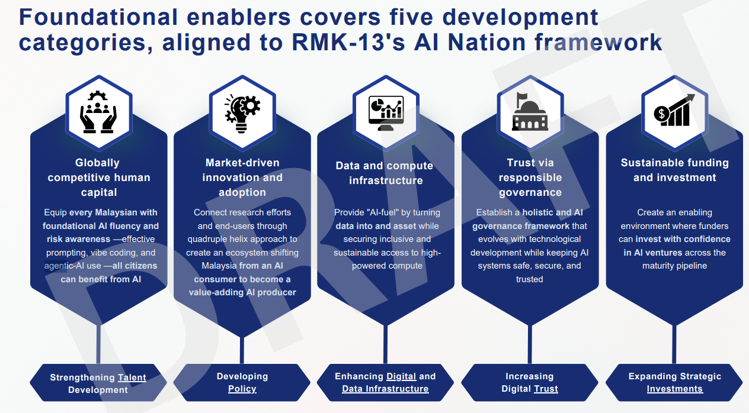
Draft of the National AI Action Plan 2030

As agentic AI becomes central to enterprise operations, Malaysia’s manufacturing, shared services, healthcare, and logistics sectors stand to gain substantially.
Autonomous agents could optimise supply chains, strengthen compliance processes, or support SMEs with financial planning and digital adoption.
Together with supportive policy and increasing VC participation in frontier technologies, Malaysia has the potential to become a leading innovation hub for applied agentic AI in Southeast Asia.

