Founders’ Insights Series

From Subang to 15 Countries: What Aonic's Journey Tells Us About Building for Impact

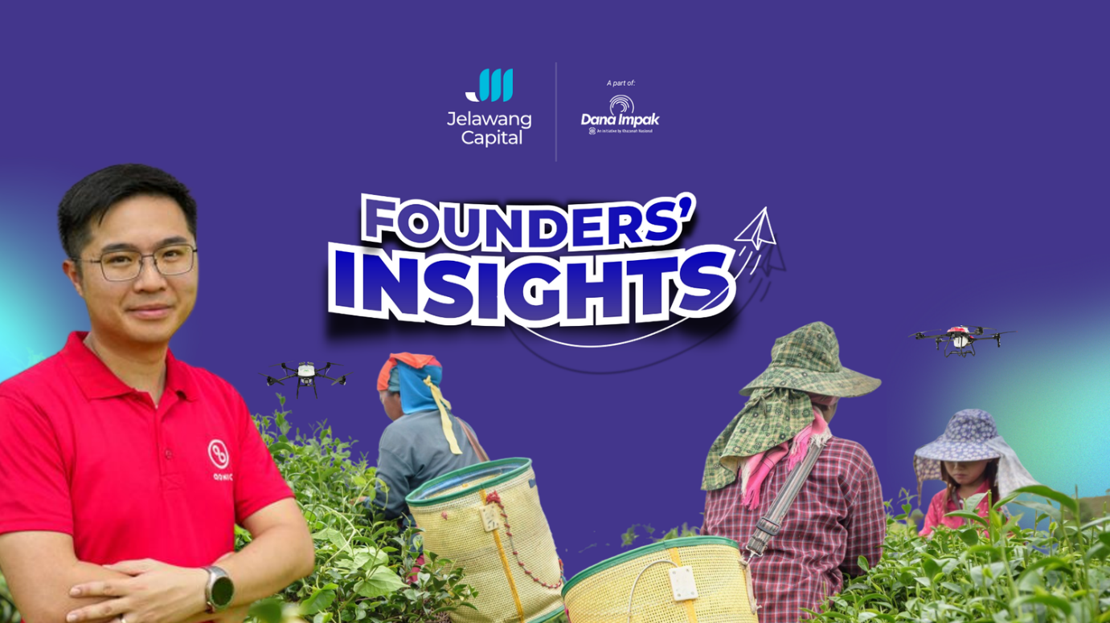
A decade ago, Cheong Jin Xi had a vision to make drones more accessible to the masses. Today, Aonic operates across 15 countries, holds major contracts with Malaysian plantation groups, and is profitable. But part of the story that doesn’t usually make the headlines is what’s happening in the paddy fields of northern Malaysia.

The problem that shaped the company
Malaysia’s agriculture sector has long faced a structural challenge that no policy document fully captures: the people doing the hardest physical work are getting older, and their children are leaving. For smallholder paddy farmers in states like Kedah and Perlis, applying pesticides and fertilisers means carrying a heavy backpack sprayer across uneven terrain, often in the heat, with direct chemical exposure. It is physically punishing work, and for decades, there was no practical alternative.
Cheong saw this not as a social problem but as an engineering one. If you could automate the spraying, you could remove the labour constraint entirely. Aonic’s Mist Drone, built for blanket spraying in open-field crops, is up to 20 times more efficient than manual methods in paddy fields. Its locally engineered and manufactured Oryctes drone, now known as Mist Tec, delivers point-to-point precision spraying at eight times the efficiency of manual labour for crops like oil palm and durian. Both are supported by proprietary software like Airamap Desktop and the Mist Flight App.
Aonic has also made inroads with agricultural companies that operate at a larger scale. In large plantation sites, applications of chemicals were previously done manually with human labour. This made it difficult for companies to gather data on when and how much chemicals were applied.
Mist Tec solves this by automating input application and gathers the data for each individual tree and field, providing useful information to growers on maximising efficiency and production.
That understanding came from years of direct fieldwork. “This was during the first five years of our operations,” Cheong recalls. “Such hands-on experience shaped how we built our solutions. By running fieldwork ourselves, we understood exactly where automation could transform operations.”
Cheong sees the shift as structural rather than incremental. “Farmers already understand the value, banks offer financing, cooperatives provide grants, and governments subsidise mechanisation,” he says. “What once felt like pushing uphill has grown into industry-wide momentum.”

What scale looks like on the ground
Aonic’s growth metrics are well documented with triple-digit CAGR since 2022, over USD60 million in annual revenue and profitable since 2023. In a recent announcement, the company secured USD10 million in funding during a Series A round led by Kairous Capital. But what the headline figures do not capture is the infrastructure the company has been quietly building underneath them.
Aonic is not just selling drones. It is building the conditions under which drone adoption becomes self-sustaining by setting up a wide network of 3S (sales, service, and spare parts) centres where customers can reach Aonic quickly, offering financing for smallholders who cannot absorb upfront costs, and training so they can fly effectively.
The scale of the opportunity was always clear to Cheong, even when the path was not. “As adoption grew, it became clear that the opportunity in Southeast Asia’s agriculture sector was massive,” he says. “Most farms still relied on slow and inconsistent manual labour. With the right backing, we could scale quickly and build a more automated, data-driven agricultural ecosystem.”

The ecosystem effect
One of the less visible outcomes of Aonic’s model is the micro-economy it has seeded in agricultural communities. Because purchasing a drone outright remains expensive for most smallholders, a class of local service providers has emerged where individuals use Aonic’s Mist Drones to offer spraying services to neighbouring farms. They are, in effect, small business owners created by the existence of the technology.
At the other end of the scale, Aonic holds contracts with major plantation operators in the country. Malaysian-made drone technology is now integral to the operations of one of the country’s largest agribusinesses.
What emerges is a complete cycle from national capital that is channelled through institutional fund managers to spur homegrown innovations. Today, drone technology benefits all layers of the agricultural ecosystem, from the largest plantation groups down to a smallholder farmer in Kedah who no longer has to carry a backpack sprayer in the midday sun.

Why the next generation is coming back
Perhaps the most telling signal of Aonic’s impact is one that does not appear in any financial statement. Across communities where drone adoption has taken hold, younger Malaysians who had left farming behind are returning. Not because farming has become easier out of necessity, but because it has become viable as a livelihood. For some, it has become a business.
For policymakers thinking about rural economic resilience and the long-term sustainability of Malaysia’s food production base, this is the outcome that matters.
It is a distinction Cheong returns to when describing Aonic’s early years. “Being an early mover meant our biggest challenge was not selling agricultural drones, it was building the market.” He added that farmers were not sure drones would work for their crops and questioned their commitment especially since banks wouldn’t finance the technology.

What this means for the ecosystem
Aonic’s trajectory reflects a broader thesis about how capital should work in Malaysia’s innovation economy. The company did not scale because of a single funding event. It scaled because it built the right foundations: a wide network of 3S centres, an end-to-end product ecosystem, a financing solution for the market it was trying to serve, a training and certification infrastructure, and a strong supply chain.
Kairous Capital, backed by Jelawang Capital under the Emerging Fund Managers’ Programme, recognised this when it funded Aonic. The investment thesis was not speculative. It was grounded in a company that had already demonstrated it could deliver measurable outcomes at scale, in sectors that matter to national development.
Cheong is direct about what that backing made possible. “We help farms work faster, more accurately, and with full visibility. VC capital enabled faster expansion. Our investors also provided guidance on go-to-market strategy, introduced us to other funding partners, and shared valuable external perspectives from their experience with other portfolio companies.”
Aonic’s path reflects what is possible when determination, innovation, and the right partners come together. That is the kind of capital deployment that builds an ecosystem over time.

