Venture Capital in 2026: Three Structural Shifts Taking Shape
Southeast Asia recorded its lowest annual venture capital deal count since 2018 last year. That is the headline. But that data point does not describe the full picture.
Capital did not exit the market. It became more selective. Funding was concentrated toward higher-conviction bets, sectors with structural demand, and markets where policy and fundamentals were aligned. DealStreetAsia’s (DSA) 2025 Southeast Asia Startup Funding Report shows deal flow had stabilised across parts of the region during the second half of last year.

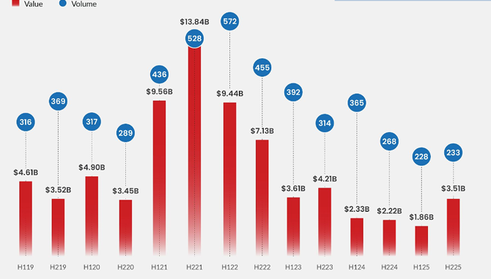
Equity deal volume and value per semester points to deal flows stabilisation in the second half of 2025. Source: DealStreetAsia, 2025 SEA Startup Funding Report

In Malaysia, total equity funding reached $257 million from 40 deals in 2025, up from $141 million across 58 deals in 2024. Concurrently, foreign VCs are looking to deploy capital into Malaysian startups for the first time¹, policy catalysts like the New Investment Incentive Framework² (NIIF) are taking hold, and the broader investment environment has strengthened.

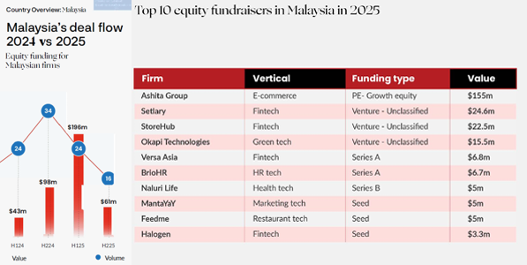
Equity deal volume vs value per semester, 2024-2025 and top 10 equity fundraisers in Malaysia in 2025. Source: DealStreetAsia, 2025 SEA Startup Funding Report.

The concentration is visible in the data: fewer deals, larger cheques, more late-stage rounds. On the surface, it looks like cautious investors simply being more selective.

The question for 2026 is not whether activity is recovering. It is what kind of market is forming after the reset.
Three structural shifts are visible.

1. A Clear Flight to Quality
As DSA puts it, tougher times create resilient founders. That resilience is now showing up at the fundraising table.
The types of companies getting funded have changed. The startups attracting capital today tend to have credible unit economics, distribution through strategic partners, and founders who built operational discipline through the downturn, not in spite of it.
There is a noticeable tilt toward business models that generate recurring revenue and have clear monetisation: business-to-business (B2B) platforms, supply chain solutions, enterprise software, and sector-specific fintech. These aren’t necessarily the most exciting pitches in the room, but they tend to retain customers and defend margins.
“Local founders are exhibiting enhanced technical expertise and regional aspirations, reflecting the evolving maturity of Malaysia’s innovation ecosystem. Institutional investors are placing greater emphasis on disciplined go-to-market strategies, capital efficiency, and governance preparedness. Expectations are high for founders to be able to be receptive to feedback and to adapt their business plans, as access to capital becomes more discerning and oriented toward long-term sustainability,” says Vynn Capital founding and managing partner Victor Chua.
In this current climate, the fundraising bar remains high for founders. Improving sentiment has not translated into easier capital. Expectations have increased.
For fund managers, this environment reinforces the importance of discipline. Managers who maintained underwriting standards during the downturn are better positioned today. In a selective market, quality of selection and pacing of deployment become decisive.
It is a calibration period for the region.

2. AI Capital Flows Are Accelerating, and Getting More Discerning
Artificial intelligence (AI) continues to attract a disproportionate share of venture funding globally. Southeast Asia is participating in this shift, particularly in enterprise use cases such as financial services automation, logistics optimisation and industrial software. The region’s data analytics sector, comprising AI and machine learning, saw $214 million in funding value last year with a noticeable uptick during the second half, according to DSA’s report.
What has shifted, though, is investor scrutiny. There is a clear distinction between companies with proprietary technical capability and those using AI as a feature rather than a core advantage. Depth of engineering, defensible data and sustainable monetisation are being evaluated more rigorously.
For Malaysia, this is relevant in a concrete way. The country’s expanding data centre footprint, its place in the semiconductor supply chain, and government commitments to digital infrastructure create a foundation for applied AI development. There are emerging opportunities where AI intersects with sectors Malaysia has genuine strengths in: agriculture, financial services and supply chain management.
As capital concentrates in AI, fund manager capability becomes increasingly important. Evaluating technical risk and long-term defensibility requires expertise. The current cycle is likely to reward managers who combine sector knowledge with disciplined underwriting.

3. Public Listings are re-entering the Exit Conversation
Venture capital depends on realised returns. Liquidity enables capital recycling and sustains the funding cycle. None if it works without exits. And in Malaysia, that cycle is starting to close.
Malaysia is beginning to see more VC-backed companies approach listing readiness³. SkyeChip Technologies, a chip design firm backed by investors including Gobi Dana Impak Ventures Fund, has filed for listing on Bursa Malaysia’s Main Market. Additional companies are progressing toward potential listings on both Main and ACE Markets.
This development matters for several reasons.
For founders, it demonstrates that companies can scale locally and access public capital markets. For VCs, it expands exit pathways beyond trade sales or secondary transactions. For limited partners weighing whether to allocate to Malaysian VCs, it provides evidence that the ecosystem can deliver realised outcomes, not only paper valuations.
What often gets overlooked is the role VCs play long before the listing itself. Enhancing governance, establishing institutional credibility and reporting discipline, and supporting revenue diversification are built over time. These are products of years of structured support.
As more VC-backed and listing-ready companies emerge, they will strengthen Malaysia’s credibility as a growth-stage capital market in the region.

Strengthening Malaysia’s VC Ecosystem
These shifts are connected. A market that rewards quality produces stronger companies. AI investment raises technical standards, creating a generation of high-growth opportunities for those with the depth to capture them. And viable exits complete the loop, reinforcing capital recycling in the ecosystem and thereby increasing investor confidence.
In this environment, the quality of fund managers is central. Governance standards, deployment pacing, sector expertise and cross-border connectivity increasingly differentiate durable funds from cyclical participants.
Jelawang Capital’s (Jelawang) continued effort to strengthen venture infrastructure under the Malaysia Venture Capital Roadmap reflects a longer-term approach. We are building capable fund managers, attracting credible regional partnerships and crowding in private capital.
Our role is to strengthen this cycle at the top of the capital flow. Since the selection of the first five fund managers under the Emerging Fund Managers’ Programme (EMP) and Regional Fund Managers’ Initiative (RMI) in June 2025, deployment of more than RM60 million into early-stage companies has begun alongside participation of over RM30 million from additional capital providers beyond Jelawang’s own commitments. The emphasis remains on institutional standards and long-term capability, rather than short-term deal velocity.
Improving sentiment in 2026 indicates a market operating with clearer expectations and stronger filters. Selective capital, higher technical scrutiny and credible liquidity pathways together suggest a venture ecosystem that is becoming more disciplined and more durable.

Sources:
- Growing foreign VC interest in Malaysia”, The Edge Malaysia
- “Selective foreign capital flows set to back Malaysia's growth, says UOB”, NST Online
- “VC funded companies preparing for Bursa debut”, The Edge Malaysia

